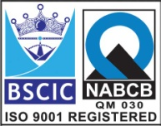****

**“EASCO” FCS Globe Valve Screwed 800#**

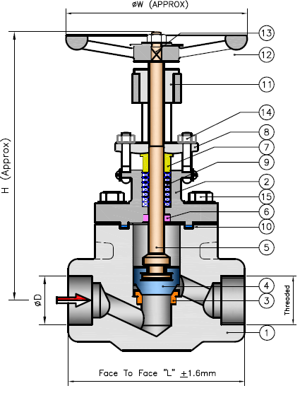

**Features: -**

* Pressure Rating: 800#
* End Connection: SE / SW
* Screwed End: As Per ANSI B 1.20.1
* Socket Weld : As Per ANSI B 16.11
* Face to Face: As Per ANSI B 16.10
* Port Opening: Reduce Port

**Testing Standard: BS 6755-I / API 598**

|  |  |
| --- | --- |
| Test Pressure in PSIG (kg/cm2) | |
| Test | Hydrostatic  ASA800# |
| Pr. Rating |
| Body | 3000 ( 211 Kg/Cm2) |
| Seat | 2000 ( 141 Kg/Cm2) |
| Back Seat | 2000 ( 141 Kg/Cm2) |

**Part List: - Design Standard: BS 5352 / API 602/ ASME B 16.34**

**Dimension: 800#**

|  |  |  |  |  |  |  |  |  |  |  |  |  |  |
| --- | --- | --- | --- | --- | --- | --- | --- | --- | --- | --- | --- | --- | --- |
| **No.** | **Part Name** | **Materials** |  | **Size** | **15** | **20** | **25** | **32** | **40** | **50** |  |  |  |
| **01** | Body | A105 /  A182 F 304/316/304L/316L |  | **L** | 90 | 94 | 108 | 126 | 126 | 142 |  |  |  |
| **02** | Bonnet |  | **D** | 22 | 27 | 34 | 42 | 49 | 61 |  |  |  |
| **03** | Seat Ring | A276 T-410/304/316/304L/316L |  | **H** | 165 | 173 | 192 | 254 | 254 | 275 |  |  |  |
| **04** | Disc | A276 T-410/304/316/304L/316L |  | **W** | 95 | 95 | 95 | 150 | 150 | 150 |  |  |  |
| **05** | Stem | A276 T-410/304/316/304L/316L |  |  |  |  |  |  |  |  |  |  |  |
| **06** | Back Sheet Bush | A276 T-410/304/316/304L/316L |  |  |  |  |  |  |  |  |  |  |  |
| **07** | Gland Bush | A276 T-410/304/316/304L/316L |  |  |  |  |  |  |  |  |  |  |  |
| **08** | Gland Flange | ASTM A105/182 F 304/316 |  |  |  |  |  |  |  |  |  |  |  |
| **09** | Gland Packing | Grafoil / PTFE / Braided Asbestos |  |  |  |  |  |  |  |  |  |  |  |
| **10** | Gasket | SS Spiral Wound With CAF/ Graphite/PTFE |  |  |  |  |  |  |  |  |  |  |  |
| **11** | Yoke Nut | CS |  |  |  |  |  |  |  |  |  |  |  |
| **12** | Hand Wheel | Cast Iron / SG Iron / CS |  |  |  |  |  |  |  |  |  |  |  |
| **13** | Hand Wheel Nut | CS / SS |  |  |  |  |  |  |  |  |  |  |  |
| **14** | Eye Bolt & Nut | CS / SS |  |  |  |  |  |  |  |  |  |  |  |
| **15** | Body-Bonnet Bolt | A 193 Gr. B7/SS 304 |  |  |  |  |  |  |  |  |  |  |  |

**Due to continuous development Program, the design & data given in this leaflet are subject to change without prior notice.**

**ANITA ENGINEERING WORKS**



58-59, Narayan Estate, Opp. Shree Ram Estate, Nr. CMC Ltd. Odhav, Ahmedabad-382415, Gujarat, India

Phone: +91 79 22974101, Fax: +91 79 22875014

Email: eascovalves@gmail.com, eascovalves@yahoo.com, Web: [www.eascovalve.com](http://www.eascovalve.com)